

Employability & Functional Skills Tutor
Job Pack

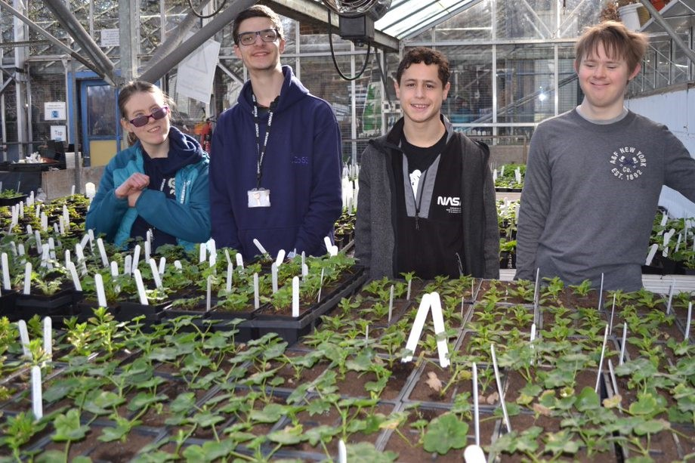

Introducing Harington
Harington is an Ofsted registered specialist college based in North London rated good, working with around 54 young people with learning differences, aged 16-25. Our mission is to create an inclusive environment, that delivers outstanding personalised education, learning, and support, which leads to further education, employment opportunities, and a fulfilling life for each of our students.

We specialise in horticulture, retail and general employability. Our students undertake individualised learning programmes and supported internships that lead to vocational qualifications and achieving other aims. We support the wellbeing of our young people through providing mentoring, counselling, enrichment and other one-to-one support.

Our charity has two learning centres in Highgate and Hornsey. We also operate a gardening business and two charity shops, providing income for our charity, work experience placements for our students and employment for 14 young people. We work with local employers and partners to provide work experience and other opportunities for our students.

The Role

We have a wonderful opportunity for a new Employability & Functional Skills Tutor to join our team. As a Tutor, you will play a crucial role in guiding and inspiring our Pre-Supported interns and Supported interns as they journey towards meaningful employment. You will facilitate a supportive learning environment where they are immersed in real workplace settings, receiving continuous feedback and hone their employability skills. Your dedication and expertise will equip our young people with the confidence and competencies needed to thrive in adulthood and competitive employment.

The Person

You will be passionate about empowering individuals to achieve their full potential in the workplace.
Our Employability programme offers a blend of classroom-based learning and hands-on experience within a real workplace environment including the Harington Gardeners and/or the Charity Shops. You will be able to deliver this programme with a track record of successful employability and Functional Skills outcomes for young people.
You are an energetic, organised, and positive team player, similarly comfortable working independently. It is a very varied role and one that needs calm focus as well as spontaneity and initiative.
This is a full-time role.

Our Benefits

In addition to excellent staff training, our employees are also rewarded with various other benefits offered as part of your employment:
- Confidential employee assistance programme
- Cycle to Work Scheme
- Fully paid for DBS
- Contributory pension scheme

Confirmation of appointment is subject to a satisfactory 6 month probation period.

Equality, Diversity & Inclusion

We value diversity and positively welcome applications from all backgrounds. This will help ensure our workforce better reflects the diverse wider community we support. Applicants who declare a disability and meet the minimum criteria for the role will be guaranteed an interview.

Safeguarding

We are committed to safeguarding and promoting the wellbeing and safety of our students and our staff. We expect everybody working for the Harington to share this commitment. The successful applicant will be required to undertake an enhanced disclosure through the Disclosure and Barring Service for applications of employment as part of our safeguarding procedures.

Some of our positions involve regulated activity relevant to vulnerable children, adults and young people. It is a criminal offence for people who are barred from working in regulated activity to apply for roles that require them to work unsupervised with that particular group. Our vacancies are exempt from the Rehabilitation of Offenders Act 1974.

How can you apply?

To apply please upload a CV and a covering letter showing how you meet all of the essential criteria in the person specification in a maximum of 1000 words.

All offers are conditional and subject to satisfactory pre-employment checks and references including an enhanced DBS check. The salary range advertised is based on the full-time equivalent and appointment on the scale is dependent on the role, qualifications and experience.

Job Description and Person Specification
Job Title: Employability and Functional Skills Tutor
Salary: £30,171.43 to £36,669.69
Days: 5 days per week
Contract Term: Permanent
Reports to: Education and Training Manager
Location: Highgate, London
Closing date: 9:00am on 30th May 2026
Are you passionate about empowering individuals to achieve their full potential in the workplace? Harington is seeking a dedicated Employability & Functional Skills tutor to join the team and deliver an impactful Employability curriculum.

Harington is a leading and trusted charity, supporting students with learning differences to develop life skills.

We provide individual education, training, and support across a range of activities including retail, horticulture and employability, delivered from inspirational places and supported by a passionate team.
Our Employability programme offers a blend of classroom-based learning and hands-on experience within a real workplace environment with the Harington Gardeners and/or the Charity Shops.

As an Employability tutor, you will play a crucial role in guiding and inspiring our pre-interns and interns as they journey towards meaningful employment. You will facilitate a supportive learning environment where interns are immersed in real workplace settings, receiving continuous feedback and honing their employability skills. Your dedication and expertise will equip our interns with the confidence and competencies needed to thrive in adulthood and competitive employment.

Main Duties and Responsibilities
- To effectively plan and deliver an employability curriculum whilst embedding functional skills (Entry 2-Level 2) and/or delivering Maths and English qualifications at these levels.
- Provide engaging teaching sessions that promote skills development and independence in the workplace.
- Implement appropriate assessment, target setting, recording, reporting and evaluation of the progress of the interns and students you teach.
- Identify interns skills to enable them to participate in a variety of work-based tasks to build marketable, competitive skills leading to employment.
- Collaborate with the employers (Gardeners and Charity Shops) to create meaningful internship opportunities and facilitate successful work placements.
- To work alongside job coaches to perform specific workplace analysis, job analysis, task analysis, and job matching activities.
- To seek appropriate future employment consistent with the interns interests and skills.
- As a personal tutor, be responsible for the emotional and social welfare of the interns.
- Work with parents, local authorities and other supported internship stakeholders to support the progression of the interns and students you teach.
- To demonstrate a commitment to the safeguarding of children and vulnerable adults in line with the policies and practices of Harington.

Person Specification

Method of Assessment – A = Application Form, I = Interview, T = Task
Qualification and Training

Diploma in Education and Training (DET), or alternative equivalent teaching qualification. | (E) | A
Recent experience of students successfully moving onto paid employment | (E) | A, I
Qualified in TSI (training in systematic instruction) | (D) | A
Experience
Recent Outstanding/Good teaching experience with students with special educational needs and/or learning differences | (E) | A, I
Proven track record of devising a curriculum, writing schemes of work and session plans that demonstrate skills building over time | (E) | A, I
Experience of creating personalised learning programmes for students with learning differences | (E) | A, I
Experience of providing group and 1:1 tutorial support or coaching | (E) | A, I
Experience of working with teams to set and maintain a positive culture | (E) | A
Strong track record of achieving employability outcomes for young people | (E) | I
Skills and Attributes

Strong communicator verbally, in writing and using various IT tools with a diverse group including Senior Managers, other professionals, young people and parents. | (E) | A
Strong leadership skills including with young people. | (E) | A, I
Good administration, IT and organisational skills with good experience of using MS office software. | (E) | A, I
Able to quickly identify problems, think flexibly and resolve issues. | (E) | A, I
Solutions focused with ability to work under pressure | (E) | A
Ability to work on own initiative and as part of a team. | (E) | A
Personal qualities, communicating and relating to others
Flexibility to cope with the varying demands of the role, managing time effectively to achieve the desired results. | (E) | A, I
Effective negotiation and persuasion skills. | (E) | A
A strong track record of building and maintaining relationships with parents, colleagues and external stakeholders | (D) | A
Safeguarding

Be able to display an awareness, understanding and commitment to the protection and safeguarding of young people and vulnerable adults. | (E) | A, I
This post requires a Disclosure and Barring Service Check at an Enhanced level for children and adults. | (E) | A, I
Other

Have an understanding of and be able to demonstrate a commitment to Equal Opportunities and Diversity. | (E) | A, I
Promotion of and compliance with Harington policies and procedures. | (E) | A
To undertake such other duties of a similar nature as required by the Principal. | (E) | A

Notes
This list of duties is not intended to be exhaustive but simply highlights some of the major tasks of the post.

